**What is Data Model in Tableau-**

Data model is nothing but the structure that has been created at data source level using Logical (Relationship) Layer or Physical Layer.

**What is Logical Layer and Physical Layer-**

**Logical Layer-**This is the default view that we see in first on our data source page canvas. This model uses the relationships or noodles to combine the data.

**How it looks on Tableau-**

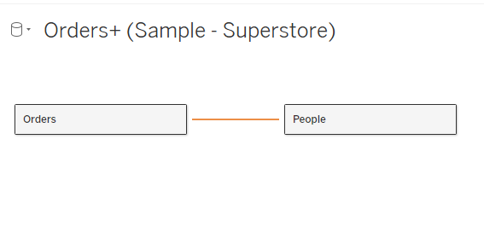

**Benefits of Relationships**

- Allows to use data sources independently (it maintains the same level of details of all data sources)

- Lists all the columns from all the data sources same as they are available at source level unlike the joins where data gets filtered and differ from source level.

- They do not require us to select a join type.

Limitations of Relationships

- Relationships do not give the option to choose the join type.

**Physical Layer-**This is the next level or layer in data model that combines data using joins or union. This was the default view before Relationship Model introduced by Tableau in 2020 versions.

To view the Physical layer we have to double click on Logical layer.

View on Tableau-

